INDIVIDUAL PROJECT
Topic: School Data

- Data Cleaning, Verification and Processing
- Check duplicate records: Total school data is 565 observations and 22 variables. Disadvantage is a variable to make it possible for R to identify Levels as a classification group and not a numerical number, Levels was converted to a factor. This is useful for summarizing and comparing groups.
- Schools were grouped into three categories: Low, Medium and High economic disadvantage. The mean percentages increased across categories: Low group had the lowest disadvantage medium group was higher, High group had the greatest disadvantage.
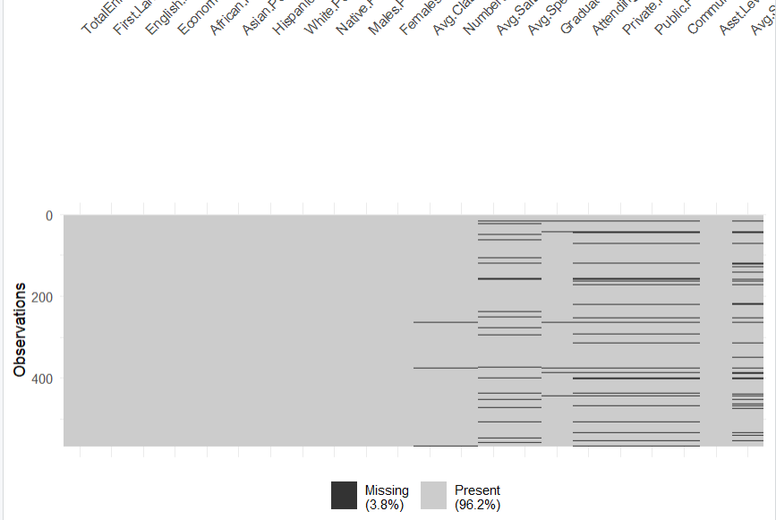
The above dataset graph shows the present 96.2% and missing 3.8%.
- The total missing values are 469.
- Data summary to the school. Data, which variable (column) has the highest number of missing values are 22
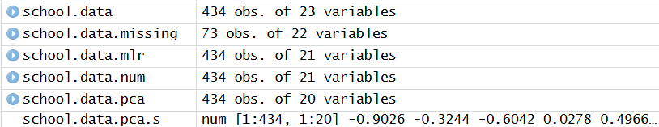
- Subset of the school.data missing values are 73 schools missing AVG.SAT values. The variable with the highest number of missing values was Avg.SAT. This subset, named school.data.missing, includes 73 observations.
- The number of rows school data is missing is 73.
- histogram of Economically.Disadvantaged.Pct from data.school.missing
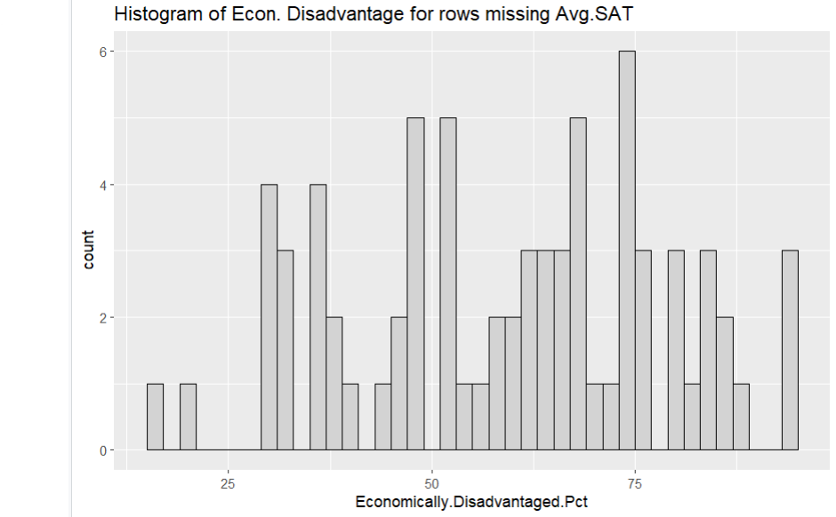
Schools with high economic disadvantages are more likely not to report SAT scores. A significant percentage of these schools have higher experiences of economic disadvantage, as shown by SAT results.
- Records that contain missing values in school.data and show the remaining record count are 434.
- Apply datasummary function again to school.data again to confirm that the missing values are removed.
> # 1i. Confirm missing values removed
> sum(is.na(school.data))
[1] 0
j) Male and female is accurate than the race.
k) Low Medium High
150 140 144
l) EconDisadvantage.Levels count avg_econ
<fct> <int> <dbl>
Low 150 8.92
Medium 140 21.2
High 144 48.4

- Data Visualization and Insights

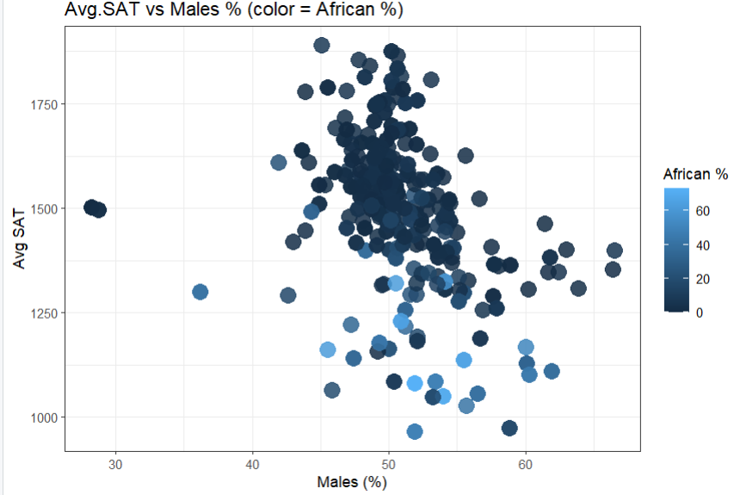

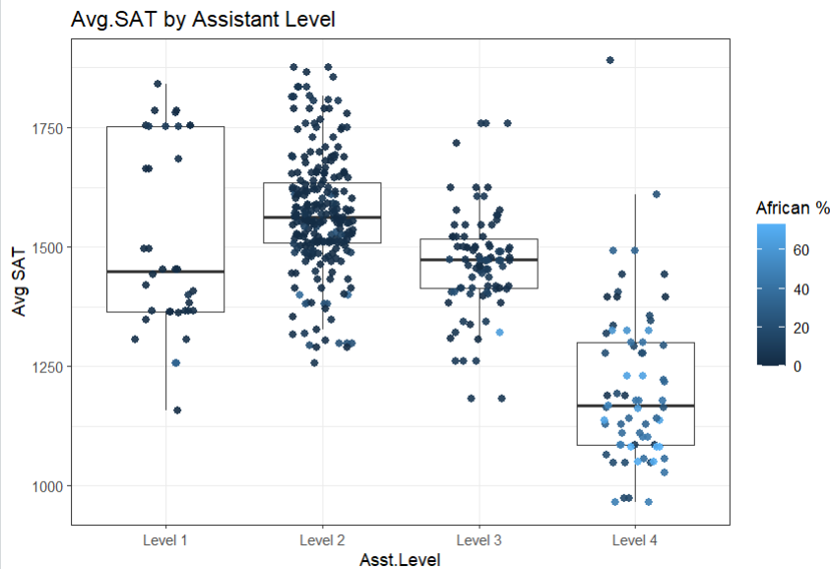

- The row name of the school is 117 in the dataset, with the average SAT of 1841.
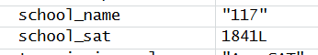

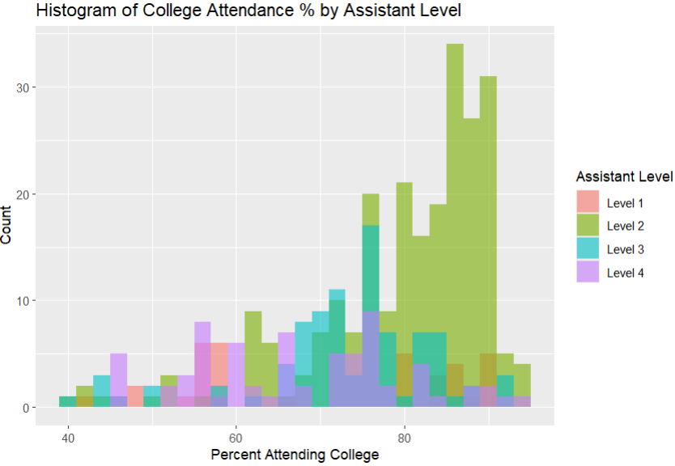
Higher assistant levels 1 and 2 have higher college attendance percentages, while lower assistant levels 3 and 4 show lower percentages.

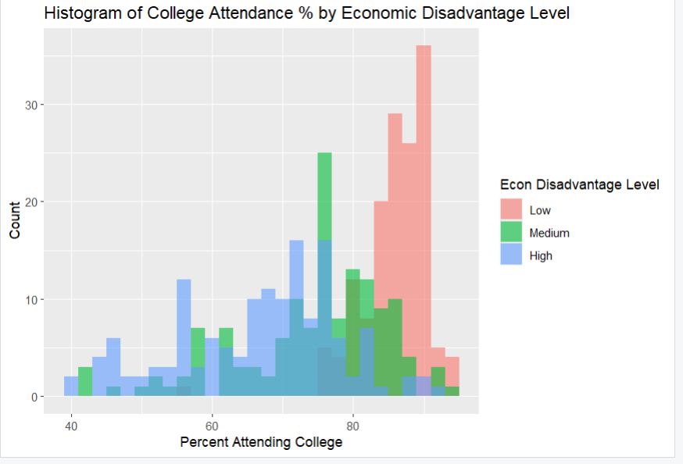
Schools with the greater economic disadvantage have lower rates of college attendance.
- Creating a new data frame
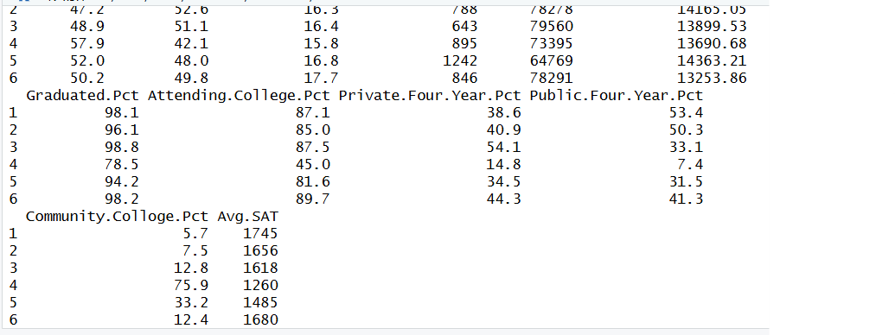
- Correlation heatmap
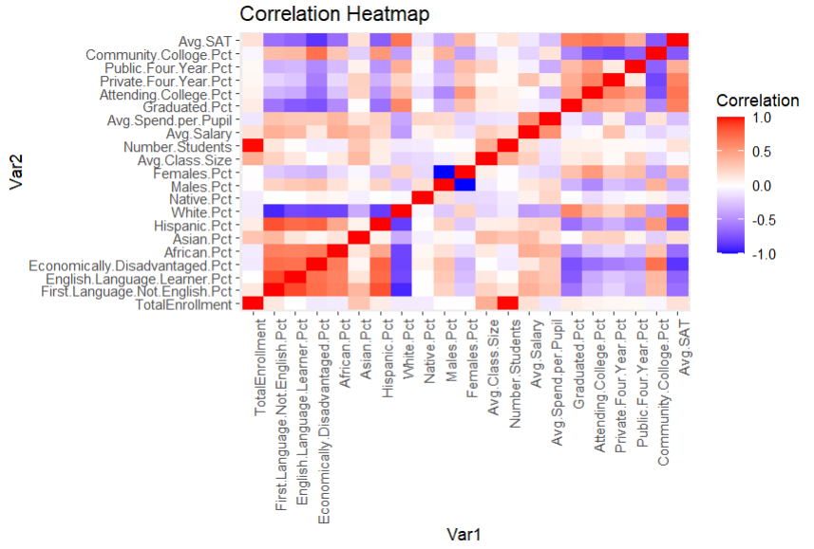

- Two variables that have highest and lowest correlation coefficients
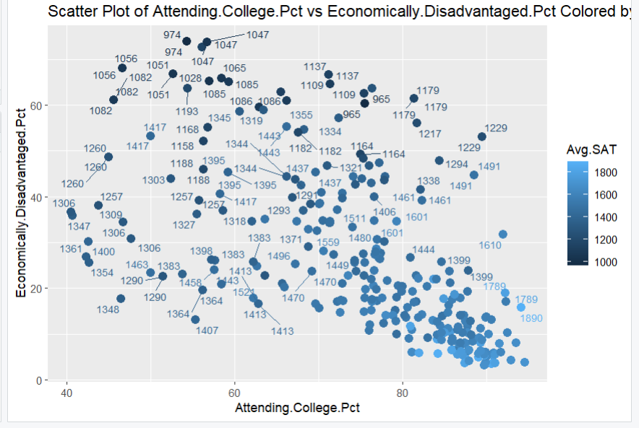

- Principal Component Analysis
- Create a new data frame
> school.data.pca <- school.data[, !(names(school.data) %in% c("Asst.Level", "Avg.SAT", "EconDisadvantage.Levels"))]

b) The mean values were all approximately 0 and the standard deviations were around confi rms that the normalization was done correctly.
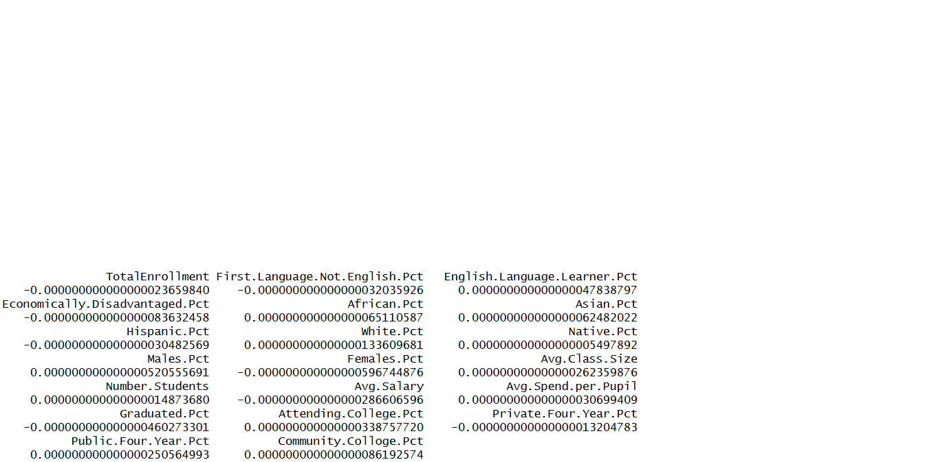

- principal component analysis
pcs <- prcomp(school.data.pca.s, scale = FALSE)

- The total variance of all principal components is 20.

- Variables
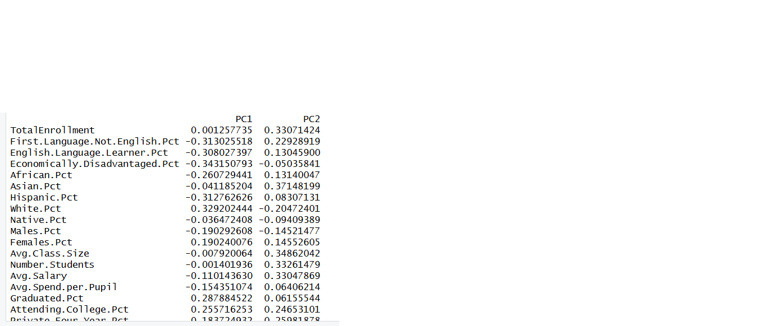
PC1 loading the highest loading variable is 0.343150793 and PC2 highest variable is 0.37148199.
- > scores <- data.frame(pcs$x)
> scores <- cbind(scores, Avg.SAT = school.data$Avg.SAT)

- Scatter plot for PC1 vs PC2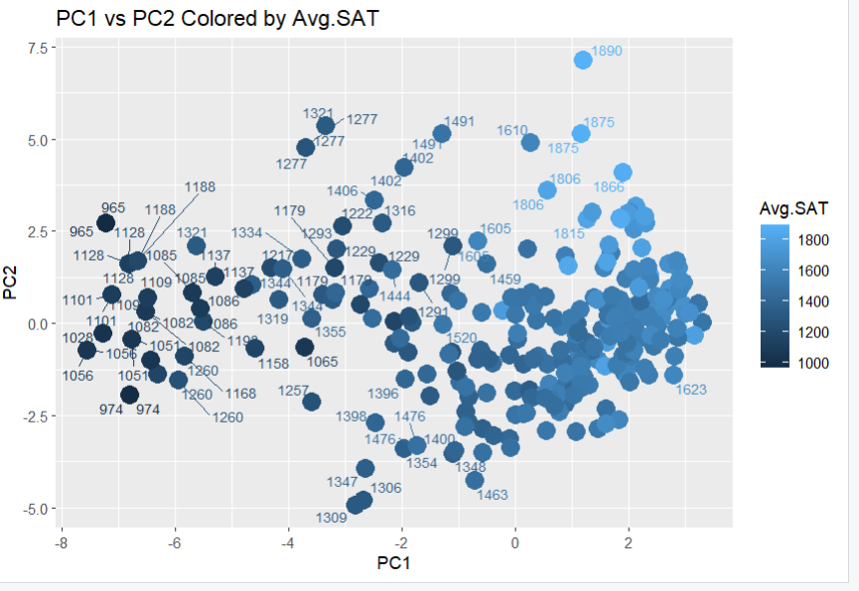

- Two scatter plots (PC1 vs PC2 and PC2 vs PC3) side by side
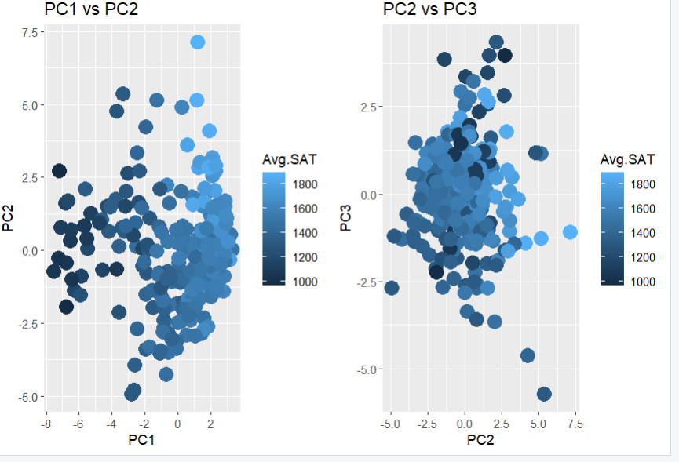
For schools with high average SAT scores (over 1600), the PC1 vs. PC2 scatter plot shows better separation. This is because of the PC1 and PC2 capture the variations related to academic achievement and explain the majority of the dataset's variance. The difference in the PC2 vs. PC3 visualization is weaker because PC3 explains less variance.
- Predictive Models using Multiple Linear Regression
- Two Variables
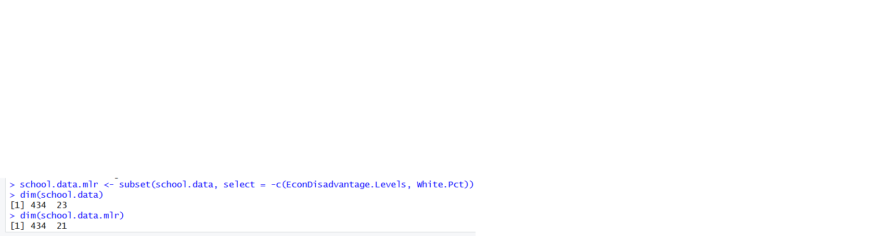

- Split data into 60% training and 40% holdout sets. To ensure accuracy, the data was effectively divided into 60% training and 40% holdout/testing using set.seed.

- i. Full model:
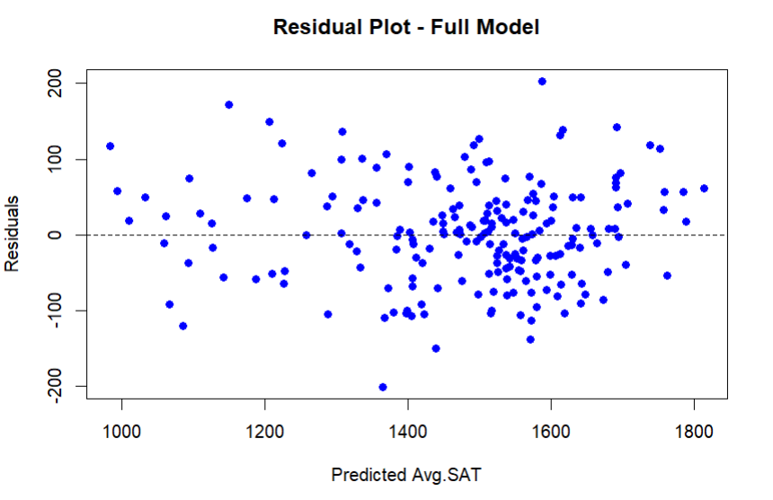
The residual plot for this model showed that the residuals are somewhat randomly scattered, but there is uneven spread and some outliers.
ii. Split wise model:
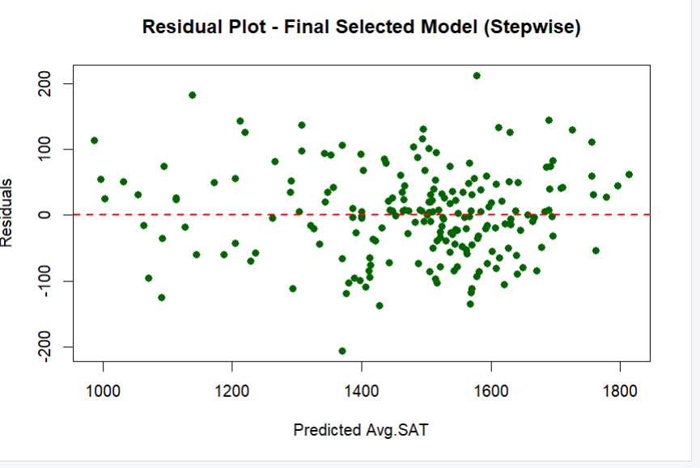
The stepwise model has a smaller set of the most relevant predictors. This model removed predictors that did not significantly improve the model making it simpler and easier to interpret.

iii. Ridge Regression Model:
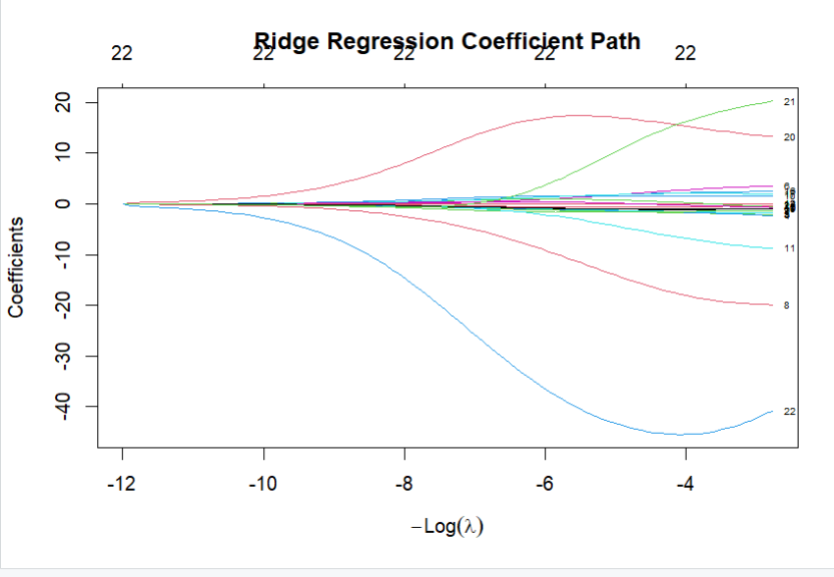
Although Ridge usually showed lower training error, controlled shrinkage could cause it to
perform somewhat worse on the holdout set. However stable, this model is not abundant.

iv. Lasso model:
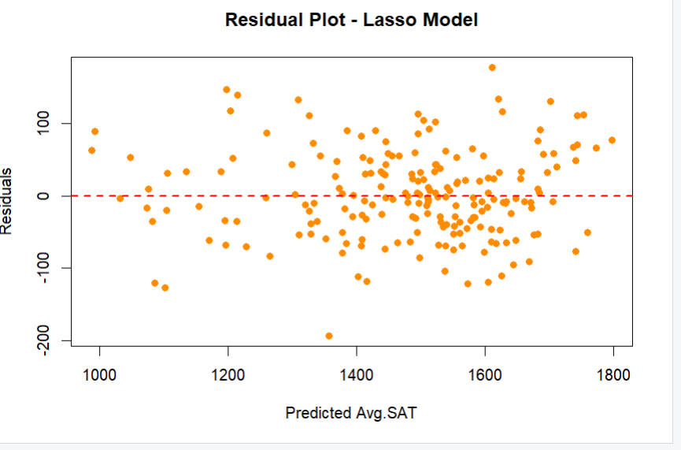

The Lasso model performed variable selection by shrinking some coefficients to zero, effectively removing unimportant predictors.

v. Comparing the two residual plots from full model and Lasso model, compared to the entire model, the Lasso model has a distribution that is more even and fewer major outliers.
As a result, the Lasso model offers higher generalization and prediction stability.
vi. Creating the new data frame, The Lasso model provides a balance between prediction accuracy and model simplicity by removing unnecessary predictors. Its holdout error is competitive, showing strong generalization to unseen data. Therefore, the Lasso model is the best choice for production use.

